**IT_CASE 1:  For creating account**

**IT_CASE 2 : View Details**

**IT_CASE 3 : Select Centre**

**IT_CASE 4 : Book Vaccine Slot**

**IT_CASE 5 : Get Vaccinated**

**IT_CASE 6: Show Beneficiary**

**IT_CASE 7: Add Vaccine Stock**

**IT_CASE 8 : Display Vaccine Stock**

**IT_CASE 9 : Delete Fully Vaccinated Beneficiaries**

**IT_CASE 10: Display non Vaccinated Beneficiaries**

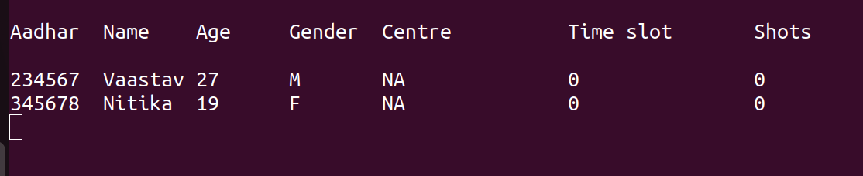

**IT_CASE 11 : Display Fully Vaccinated Beneficiaries**

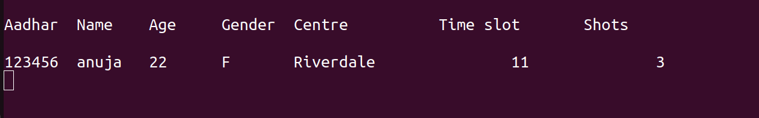

**IT_CASE 12 : Display Today Vaccinated Beneficiaries**

